Q1) Explain the concept of receptive fields in CNNs and their significance in feature extraction
Ans -
In CNNs, a receptive field refers to the region of the input image that influences the activation of a particular feature in a network (i.e. neuron + convolutional layer ) is sensitive to.

There are two types of receptive fields:

- Local receptive field : The input image is the pixel intencites, which are the input neurons.In a 1st convolutional layer, each neuron is connected to a local region of the input neurons through a set of learnable weights (filters/kernels).These weights are convolved with the input data to compute the neuron's output. The local region moves across the input space as the convolution operation is applied.
- global receptive field: This expansion is achieved through stacking multiple layers with convolutional operations.
As the network processes the input data through multiple layers of convolutions and pooling, the receptive field of each feature grows, allowing the network to capture increasingly complex patterns and relationships within the input data.

The early layers capture low-level features such as edges, corners, and textures, while deeper layers combine these features to form more complex and abstract representations. The receptive fields play a crucial role in this process, as they determine the spatial scope over which features are detected.

Q2) Discuss the challenges of overfitting and underfitting in CNNs and strategies to address them.
Ans-
Overfitting means that the neural network performs very well on training data , but fails as soon it sees some new data from the problem domain. Underfitting, on the other hand, means, that the accuracy on the validation set is higher than the accuracy on the training set. Additionally, if the whole model performs bad
.
- Too complex model architectures, insufficient data, or excessive training epochs can contribute to overfitting.
- Very simple model architectures, insufficient training, or inadequate feature representation can lead to underfitting.

Strategies to Address Overfitting and Underfitting in CNNs:
- Data Augmentation:
  - For Overfitting: Augmenting the training dataset by applying random transformations to the input data (e.g., rotation, flipping, zooming) helps diversify the dataset, reducing overfitting.
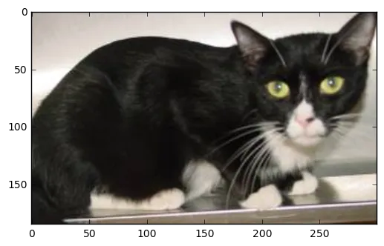
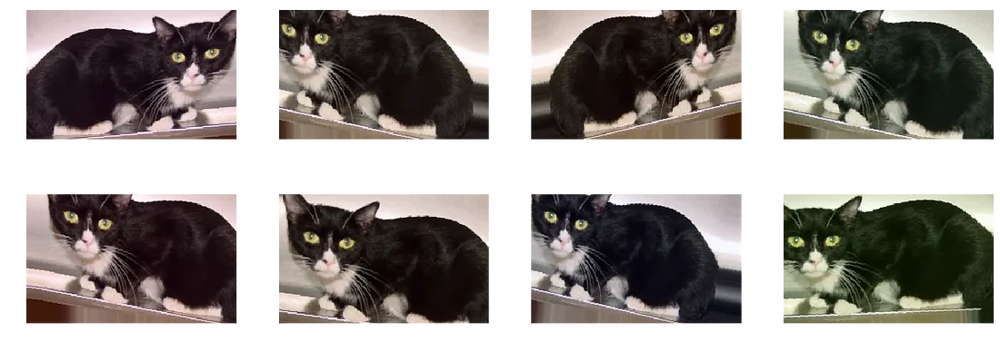

1 *
Original image of cat Augmented Image of cats
  - For Underfitting: Augmentation provides additional training samples, making the model more robust and preventing underfitting.

- Regularization Techniques:
  - For Overfitting: Techniques like dropout (randomly deactivating neurons during training) and L1 & L2 weight regularization (penalizing large weights) help prevent overfitting by introducing a level of uncertainty and preventing the model from relying too heavily on specific features.
  - For Underfitting: Regularization is often used to address overfitting, it can also prevent underfitting by constraining the model's capacity and encouraging it to learn more representative features.

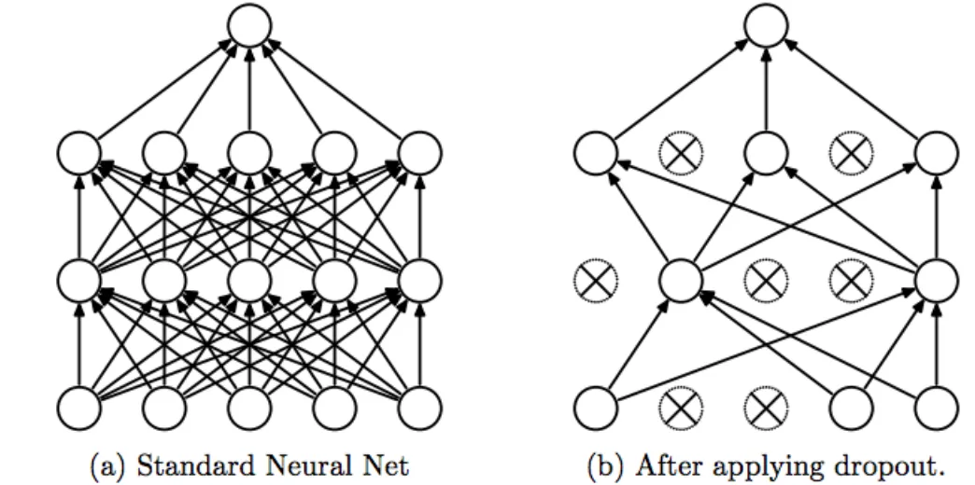
- Appropriate Model Complexity:
  - For Overfitting: Reducing the model's complexity by decreasing the number of layers or neurons can prevent overfitting, especially when dealing with a limited amount of data.
  - For Underfitting: Increasing the model's capacity by adding more layers or neurons may help address underfitting, allowing the model to capture more complex patterns in the data.
- Early Stopping:
  - For Overfitting: Monitor the validation performance during training, and stop training when the validation accuracy starts to degrade, preventing the model from overfitting the training data.
  - For Underfitting: Early stopping may not be as relevant for underfitting, as the model is not likely to improve significantly with more training. Adjusting the model complexity or other hyperparameters might be more effective.
- Increase Training Data:
  - For Overfitting: If possible, acquiring more training data can be effective in reducing overfitting by providing a broader representation of the underlying patterns.
  - For Underfitting: More training data allows the model to better generalize from diverse examples, potentially improving performance on both training and validation sets.

Q3) Describe the concept of weight sharing in CNNs and its implications for parameter efficiency.
Ans-

- In a traditional neural network, each connection between neurons has its own set of weights.
- However, in convolutional layers of CNNs, weights (learable parametes) sharing is employed by using a small set of filters (ex. 2x2) that slid across the entire input. Each filter extracts certain features (edges, textures, patterns) from different spatial locations, and the same set of weights is applied to these different locations.

- For example : In a 4x4 image and a 2x2 filter with a stride size of 2, this would mean that the filter (which has four weights, one per pixel) is applied four times, making for 16 weights total. A typical application of weight sharing is to share the same weights across all four filters.

Implications for Parameter Efficiency:

- Parameter Reduction: Weight sharing drastically reduces the number of learnable parameters in the model. Instead of having separate parameters for each spatial location, the same set of parameters is reused across the entire input. This not only saves memory but also makes the model more scalable and computationally efficient.
- Translation Invariance: Weight sharing contributes to the translation invariance property of CNNs. Since the same filter is applied across different spatial locations, the network becomes less sensitive to the exact location of features in the input data. This is particularly important for tasks like image recognition, where the position of an object in an image shouldn't affect its recognition.
- Feature Learning: By sharing weights, the model can learn spatial hierarchies of features efficiently. Lower layers capture local patterns, while higher layers combine these patterns to form more abstract representations. This hierarchical feature learning is facilitated by the weight-sharing mechanism.
- Generalization: Weight sharing promotes generalization, as the same set of parameters is used to detect similar patterns at different locations. This enables the model to recognize features regardless of their spatial orientation or position in the input.
- Reduced Risk of Overfitting: With fewer parameters, the risk of overfitting is reduced. The model is less likely to memorize noise in the training data and can generalize better to unseen examples.

Q4) Discuss the vanishing gradient problem in deep CNNs and techniques to mitigate it.
Ans-

The vanishing gradient problem is a challenge that arises during the training of deep neural networks, including deep Convolutional Neural Networks (CNNs). It occurs when the gradients of the loss function with respect to the weights become extremely small as they are backpropagated through the layers during the training process. This can lead to slow or stalled learning for the lower layers of the network, preventing them from effectively updating their weights and learning meaningful representations.

Causes of the Vanishing Gradient Problem in Deep CNNs:

- Activation Functions: Certain activation functions, such as the sigmoid function, squash input values to a range between 0 and 1. As the network becomes deeper, the gradients of these functions can approach zero, making it challenging for the lower layers to learn.
- Weight Initialization: Poor initialization of weights, especially in deep networks, can contribute to the vanishing gradient problem. If weights are initialized too small, the gradients may become too small during backpropagation.

Techniques to Mitigate the Vanishing Gradient Problem:

- ReLU and its Variants:
  - Rectified Linear Unit (ReLU) and its variants (Leaky ReLU, Parametric ReLU, Exponential ReLU) have become popular activation functions in deep networks. ReLU avoids the vanishing gradient problem by allowing non-zero gradients for positive input values.
- Batch Normalization:
  - Batch Normalization normalizes the inputs to a layer, helping to maintain a stable distribution of inputs throughout training. This can alleviate the vanishing gradient problem by preventing the inputs from drifting into regions where gradients become very small.
- Weight Initialization Techniques:
  - Proper weight initialization methods, such as He initialization (for ReLU-based activations) or Xavier/Glorot initialization, can help mitigate the vanishing gradient problem by providing a better starting point for the optimization process.
- Gradient Clipping:
  - Gradient clipping involves setting a threshold for the gradients during backpropagation. If the gradients exceed this threshold, they are scaled down. This prevents extremely small or large gradients that can hinder learning.
- Skip Connections (Residual Networks):
  - Skip connections, introduced in Residual Networks (ResNets), enable the flow of information directly from one layer to another without passing through all intermediate layers. This helps in mitigating the vanishing gradient problem and facilitates the training of very deep networks.

Mitigating the vanishing gradient problem is essential for training effective deep CNNs. A combination of proper architectural choices, activation functions, weight initialization, and normalization techniques can collectively contribute to more stable and efficient training of deep neural networks.

Q 9). Explain the concept of transfer learning in CNNs and its practical applications.

Q5) Explain the concept of transfer learning in the context of Convolutional Neural Networks (CNNs). How can transfer learning be leveraged to improve the performance of CNN models, especially when working with limited datasets?
Ans-
Transfer learning is a machine learning technique where a model trained on one task is adapted for a second related task. In the context of Convolutional Neural Networks (CNNs), transfer learning involves using a pre-trained CNN on a large dataset for a specific task and then fine-tuning it on a different but related task with a smaller dataset. This approach leverages the knowledge gained by the pre-trained model on a large dataset and applies it to a new task, even when the new dataset is limited.

How Transfer Learning Works for CNNs:
- Pre-training on a Large Dataset:
  - is initially trained on a large and diverse dataset for a specific task, such as image classification on ImageNet. This model learns to extract hierarchical features that are useful for various visual patterns.
- Feature Extraction:
  - The pre-trained CNN acts as a feature extractor. The layers close to the input capture low-level features like edges, textures, and shapes, while deeper layers capture high-level features and complex patterns.
- Transfer to New Task:
  - The pre-trained model is then used as a starting point for a new task with a smaller dataset. The learned features are preserved, and only the final layers (fully connected layers) are fine-tuned to adapt the model to the specific characteristics of the new dataset.
Advantages and Benefits:
- Feature Reusability:
  - The lower layers of a CNN capture generic features that are applicable to various tasks. Transfer learning allows these features to be reused for a new task, especially when the new dataset is limited.
- Reduced Training Time:
  - Training a deep CNN from scratch on a limited dataset can lead to overfitting. Transfer learning reduces the training time and helps in avoiding overfitting by leveraging pre-trained weights.
- Improved Generalization:
  - Models trained on large datasets often capture a broad range of features and patterns. Transfer learning enhances the generalization of the model to new tasks by starting with knowledge gained from a diverse dataset.
- Effective for Limited Data:
  - Transfer learning is particularly beneficial when dealing with limited datasets. It allows the model to benefit from the knowledge learned on a large dataset, mitigating the risk of poor generalization when training from scratch with limited samples.

Practical Applications of Transfer Learning in CNNs:

- Image Classification: Transfer learning is widely used in image classification tasks. Pre-trained models, such as those trained on ImageNet, are fine-tuned for specific image classification tasks with smaller datasets.
- Object Detection: In object detection tasks, where the goal is to identify and locate objects within an image, pre-trained models can be adapted for specific object detection datasets.
- Semantic Segmentation: Transfer learning is applied to semantic segmentation tasks, where the goal is to segment an image into different regions. Pre-trained models can be fine-tuned for specific semantic segmentation datasets.
- Style Transfer: Transfer learning is used for artistic applications such as style transfer. Pre-trained models can be adapted to transfer the artistic style of one image to another.
- Medical Image Analysis: In medical image analysis, where labeled data is often scarce, transfer learning is applied to tasks such as disease diagnosis, organ segmentation, and anomaly detection.
- Natural Language Processing (NLP): Transfer learning is not limited to vision tasks. In NLP, models pre-trained on large text corpora (e.g., Word2Vec, GloVe) can be used as a starting point for specific language-related tasks.

Q6) Compare and contrast different CNN architectures such as LeNet-5, AlexNet, VGG, and ResNet, highlighting their key differences.
Ans-
These architectures have played significant roles in the development of deep learning for computer vision tasks. Here are their key differences:

1. LeNet-5: (1998)
- Designed for handwritten digit recognition.
- Consists of three convolutional layers followed by two fully connected layers.
- Introduced concepts like max-pooling and non-linear activation functions (tanh and sigmoid).
- Used relatively small filter sizes compared to modern architectures.
2. AlexNet: (2012)
- Winner of the ImageNet Large Scale Visual Recognition Challenge (ILSVRC) in 2012.
- Utilizes deeper architectures with eight layers, including five convolutional layers and three fully connected layers.
- Popularized the use of Rectified Linear Unit (ReLU) activation functions.
- Introduced the concept of dropout for regularization.
- Used local response normalization.
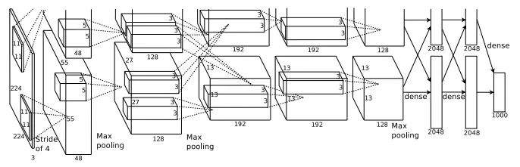
It consisted 11x11, 5x5,3x3, convolutions, max pooling, dropout, data augmentation, ReLU activations, SGD with momentum. It attached ReLU activations after every convolutional and fully-connected layer. AlexNet was trained for 6 days simultaneously on two Nvidia Geforce GTX 580 GPUs which is the reason for why their network is split into two pipelines.

3. VGGNet (2014)
- Known for its simplicity and uniform architecture.
- Consists of 16 or 19 layers with small 3x3 convolutional filters.
- Uses only 3x3 convolutional layers and 2x2 max-pooling layers.
- Achieved competitive performance in the ILSVRC 2014 challenge.
- Trained with various depth configurations.
Similar to AlexNet, only 3x3 convolutions, but lots of filters. Trained on 4 GPUs for 2–3 weeks. It is currently the most preferred choice in the community for extracting features from images. The weight configuration of the VGGNet is publicly available and has been used in many other applications and challenges as a baseline feature extractor. However, VGGNet consists of 138 million parameters, which can be a bit challenging to handle.
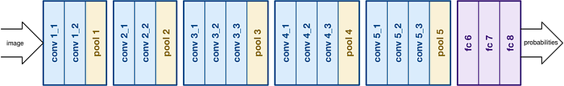

4. ResNet(2015) :
Introduced anovel architecture with “skip connections” and features heavy batch normalization. Such skip connections are also known as gated units or gated recurrent units and have a strong similarity to recent successful elements applied in RNNs. Thanks to this technique they were able to train a NN with 152 layers while still having lower complexity than VGGNet. It achieves a top-5 error rate of 3.57% which beats human-level performance on this dataset.

- Introduces residual learning to address the vanishing gradient problem.
- Utilizes residual blocks with skip connections, allowing the network to learn residual functions.
- Enables the training of very deep networks (50, 101, or 152 layers).
- Achieved state-of-the-art performance in the ILSVRC 2015 challenge.
- Widely used in various computer vision tasks due to its ability to handle deep architectures

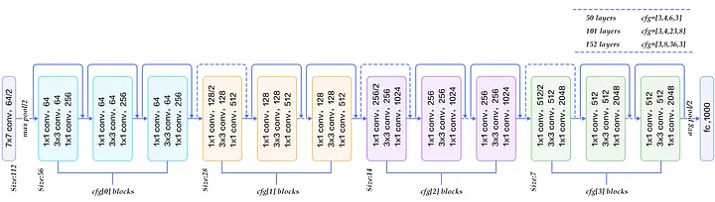
Comparison:
- Depth:
  - LeNet-5 is relatively shallow compared to later architectures.
  - AlexNet introduced deeper architectures, while VGG used even deeper networks.
  - ResNet pushed the envelope by demonstrating effective training of extremely deep networks.
- Filter Sizes:
  - LeNet-5 used small filter sizes (e.g., 5x5).
  - AlexNet introduced larger filter sizes (e.g., 11x11 and 5x5) and VGG used only 3x3 filters.
  - ResNet predominantly used 3x3 filters with the introduction of residual blocks.
- Activation Functions:
  - LeNet-5 used tanh and sigmoid.
  - AlexNet introduced the use of ReLU.
  - VGG and ResNet primarily use ReLU activation functions.
- Regularization Techniques:
  - AlexNet introduced dropout for regularization.
  - VGG relied on depth for regularization.
  - ResNet utilized skip connections to address the vanishing gradient problem.
- Vanishing Gradient:
  - LeNet-5 and AlexNet faced challenges with vanishing gradients, especially as the depth increased.
  - VGG also faced vanishing gradient issues to some extent.
  - ResNet addressed vanishing gradients effectively with the use of residual connections.
- Performance:
  - AlexNet, VGG, and ResNet demonstrated significant improvements in performance over LeNet-5, achieving top positions in the ILSVRC challenges.

Q7) Explain the role of pooling layers in CNNs and how they contribute to spatial down-sampling.

Pooling layers in Convolutional Neural Networks (CNNs) play a crucial role in down-sampling the spatial dimensions of the input data. Pooling is a form of non-linear down-sampling or subsampling that reduces the spatial dimensions (width and height) of the feature maps while retaining important information. The primary purpose of pooling layers is to decrease the computational complexity of the network and increase its translational invariance, making the model more robust to variations in the input.

Role of Pooling Layers:
- Spatial Down-Sampling:
  - The main function of pooling layers is to reduce the spatial resolution of the feature maps. This helps in reducing the number of parameters and computations in the subsequent layers of the network.
- Translation Invariance:
  - Pooling introduces translation invariance by down-sampling the feature maps. This means that small variations or translations in the input data do not significantly affect the pooled output, making the network more robust to changes in position or orientation.
- Feature Retention:
  - Despite reducing the spatial dimensions, pooling layers aim to retain essential features by selecting the most representative information from local regions. The pooling operation helps in capturing the dominant features within each local receptive field.
- Reduced Computational Complexity:
  - By down-sampling the feature maps, pooling reduces the computational complexity of the network. This is crucial for improving the efficiency of training and inference, especially in deeper architectures.

Types of Pooling Layers:
- Max Pooling:
  - Max pooling selects the maximum value from a local region in the input. It is commonly used due to its simplicity and effectiveness in retaining the most important features.
- Average Pooling:
  - Average pooling computes the average value from a local region. It can be less sensitive to noise and outliers compared to max pooling.
- Global Average Pooling:
  - Global Average Pooling computes the average value of each feature map, effectively reducing the spatial dimensions to 1x1. It is often used as an alternative to fully connected layers in the final stages of a network.

The spatial down-sampling process in pooling layers typically involves the following steps:
- Local Receptive Fields:
  - Define non-overlapping or overlapping local receptive fields over the input feature maps.
- Pooling Operation:
  - Perform the pooling operation (max pooling or average pooling) within each local receptive field. This results in a down-sampled output containing the most relevant information.
- Stride and Padding:
  - Optionally, specify a stride (the step size of the pooling window) and padding to control the down-sampling process and adjust the output dimensions.
- Output Feature Maps:
  - The output feature maps have reduced spatial dimensions compared to the input, and the pooled values represent the most important information from the local regions.

Pooling layers in CNNs contribute to spatial down-sampling by reducing the spatial dimensions of feature maps while retaining essential information. This down-sampling aids in decreasing computational complexity, increasing translation invariance, and improving the efficiency of the network for tasks like image recognition and computer vision.

Q 8). Discuss the impact of kernel size and stride on the output dimensions of convolutional layers in CNNs
Ans-
The kernel size and stride are important parameters that significantly impact the output dimensions of convolutional layers in CNNs. These parameters influence the output size , it is crucial for designing and tuning in CNN architectures.

1. Kernel Size:
The kernel size (also known as filter size) is the spatial dimension of the convolutional filter or kernel applied to the input. The kernel moves across the input data, and at each position, it performs a convolution operation.

Impact on Output Dimensions:
- Larger Kernel Size:
  - Larger kernel sizes capture larger spatial features in the input.
  - The output size will be smaller due to the increased receptive field, and the network may lose fine-grained spatial information.
- Smaller Kernel Size:
  - Smaller kernel sizes capture more fine-grained spatial details.
  - The output size will be larger, and the network may focus on capturing local patterns.
2. Stride:
Stride is the step size at which the kernel moves across the input data. A larger stride leads to a more significant spatial down-sampling, while a smaller stride results in less down-sampling.

Impact on Output Dimensions:
- Larger Stride:
  - Larger strides reduce the spatial dimensions of the output.
  - It leads to faster computation and can help in reducing the number of parameters in subsequent layers.
  - However, it may result in the loss of spatial details and features.
- Smaller Stride:
  - Smaller strides result in less down-sampling and larger output dimensions.
  - It helps in preserving more spatial details and capturing finer patterns.
  - However, smaller strides can increase the computational load and memory requirements.
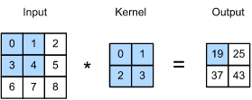
The input is a two-dimensional tensor with a height of 3 and width of 3. We mark the shape of the tensor as 3x3 or (3,3 ). The height and width of the kernel are both 2. The shape of the kernel window (or convolution window) is given by the height and width of the kernel (here it is 2x2). Stride is 1 :

Two-dimensional cross-correlation operation. The shaded portions are the first output element as well as the input and kernel tensor elements used for the output computation: ( 0x0 + 1x1 + 3x2 + 3x4 = 19 )

Formulas for Calculating Output Dimensions:
Assuming an input size of Win kernel size K, padding P, and stride S, the formula for calculating the output size Wout, along one spatial dimension is given by:

Wout = (Win−K+2P) / S +1
This formula accounts for the impact of the kernel size, padding, and stride on the output size.

Example:
Let's consider an example where the input size is Win = 32, kernel size is K = 3, padding is P = 1, and stride is S=2.
Wout = ( 32−3+2(1))/2 + 1=16
So, in this example, the output size along that spatial dimension would be Wout​=16.

Impact on CNN Architectures:
- Pooling Layers: The choice of kernel size and stride in pooling layers influences the spatial down-sampling between convolutional layers.
- Architectural Design: Kernel size and stride are crucial design choices when constructing CNN architectures, impacting the receptive field, computational efficiency, and ability to capture different spatial features.

In summary, the kernel size and stride in convolutional layers of CNNs directly influence the output dimensions, determining the spatial down-sampling and capturing characteristics of the learned features. Tuning these parameters requires a trade-off between computational efficiency, receptive field, and the preservation of spatial information.
10). How does the choice of activation function (e.g., ReLU, sigmoid, tanh) impact the performance of a CNN?
Ans-
Activation functions determine the performance of the CNN model, it introduce non-linearity to the model, allowing it to learn complex mappings between inputs and outputs. Different activation functions have distinct characteristics, and their suitability depends on the task, architecture, and data.

Common Activation Functions:

- ReLU (Rectified Linear Unit):
  - Advantages: Addresses the vanishing gradient problem better than sigmoid and tanh. Simple and computationally efficient.
  - Impact on Performance: Generally leads to faster convergence during training. Effective in capturing non-linearities in data.
- Sigmoid:
  - Advantages: Outputs values between 0 and 1, which can be interpreted as probabilities. Useful in the output layer for binary classification problems.
  - Disadvantages: Suffers from the vanishing gradient problem. Outputs are not zero-centered, leading to slower convergence.
  - Impact on Performance: May result in slower training and convergence.
- Tanh (Hyperbolic Tangent):
  - Advantages: Outputs values between -1 and 1, making it zero-centered. Mitigates the vanishing gradient problem compared to sigmoid.
  - Disadvantages: Still suffers from the vanishing gradient problem, especially in deep networks.
  - Impact on Performance: Can be more effective than sigmoid in certain scenarios. Commonly used in the hidden layers of RNNs and LSTMs.
- Softmax:
  - Advantages: Converts raw scores into probabilities for multiclass classification. Used in the output layer for multi-class classification problems.
  - Impact on Performance: Suitable for tasks with multiple mutually exclusive classes. Facilitates the interpretation of model predictions as probabilities.

Impact on Training Dynamics:

- Addressing Vanishing Gradient:
  - ReLU tends to address the vanishing gradient problem more effectively than sigmoid and tanh. This can result in faster training and better convergence, especially in deeper networks.
- Activation Saturation:
  - Sigmoid and tanh can suffer from saturation issues, where the gradients become very small for extreme input values. This can slow down training, and in the case of vanishing gradients, hinder learning.
- Dying ReLU Problem:
  - ReLU can suffer from the "dying ReLU" problem, where neurons become inactive and stop learning during training. This happens when the input to a ReLU neuron is consistently negative.

Task-Specific Considerations:

- Binary Classification:
  - Sigmoid is commonly used in the output layer for binary classification problems to produce probabilities.
- Multiclass Classification:
  - Softmax is often used in the output layer for multiclass classification tasks to obtain probability distributions over classes.

- Feature Learning:
  - ReLU is widely used in hidden layers for feature learning due to its simplicity and effectiveness in capturing non-linearities.

Experimental Exploration:

- The optimal choice of activation function may vary depending on the specific task, dataset, and model architecture.
- It is common to experiment with different activation functions during model development to identify the one that yields the best performance.

The choice of activation function in a CNN has a substantial impact on training dynamics, convergence speed, and the ability of the model to learn complex patterns. ReLU is a popular choice in hidden layers, while sigmoid and softmax are common in output layers based on the task at hand.

